**Spiked Sorrel Drink**

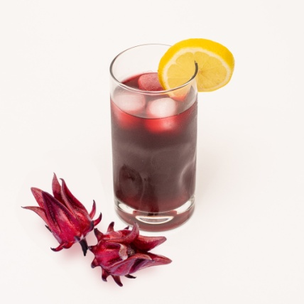

This spiked sorrel is infused with the traditional spices and the complex flavours of Angostura Aromatic Bitters. The robustness of Fernandez Black Label Rum packs the right amount of punch for this cocktail. This Strong & Spiced Spiked Sorrel (say that five times) is a definitely crowd pleaser at any event this Christmas.

**INGREDIENTS**

8 – 10 dashes Angostura Aromatic Bitters

Fernandez Black Label Rum

1 lb dark sorrel washed & deseeded

6 cups water

1 cup brown sugar

2 bay leaves

6 grains clove

2 cinnamon sticks

3 star anise

1 tsp grated nutmeg

**METHOD**

1. Add sorrel with spices to a pot on high heat.
2. Bring to a boil then reduce to low heat
3. Add sugar and Angostura Aromatic Bitters
4. Allow to simmer for 15 minutes
5. Remove from heat and allow to steep for at least 30 minutes
6. Fill glass with ice
7. Pour two parts sorrel to one part Fernandez Black Label Rum
8. Add a dash of Angostura Aromatic Bitters or Angostura Orange Bitters
9. Stir well and enjoy!